Room A Question 1
Q1 / Breast DCIS
Stem:
55y postmenopausal female with no past medical or surgical history is referred to the office for calcifications seen in the upper outer quadrant of the left breast on annual screening mammogram that weren’t appreciated on the mammogram the year prior. She denies any changes in her breasts or axillae.
Family history is negative for breast or gynecologic malignancies.
Her physical exam is unremarkable.

What is your Differential Dx?
- DCIS
- LCIS
- Invasive breast cancer
- Atypical ductal or lobular hyperplasia
- Fibrocystic changes
- Fat necrosis
Additional Workup or Studies?
- Diagnostic mammogram : Fine linear branching calcifications located near the chest wall in the upper, outer quadrant of the left breast; the calcifications appear focal and do not appear to be multicentric
- 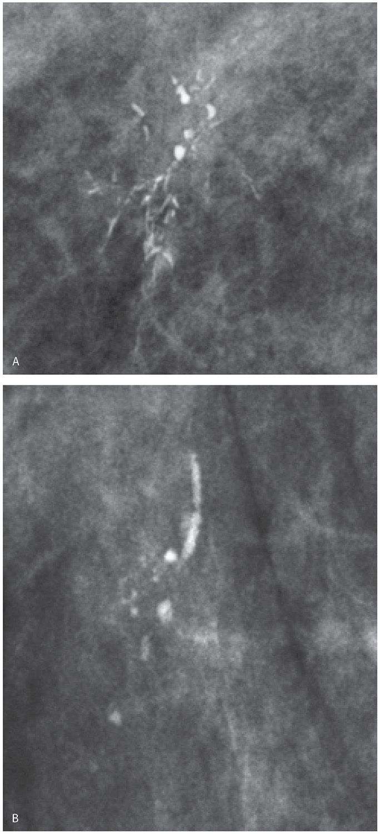
2. Stereotactic core needle biopsy: Returns as DCIS
What would you like to do now?
1. Surgery:
a. Localization
b. Breast conserving surgery with postoperative radiation (no SLNB)
c. (or) Simple mastectomy with sentinel lymph node biopsy +/- reconstruction
Pathology returns as ER/PR + high grade DCIS, what treatment you would recommend?
5 years of anastrozole
Describe Breast Conserving Surgery
1. Preprocedural localization of nonpalpable lesions.
2. Plan incision on lesion depth and location, with consideration of future mastectomy incision.
3. Excise the localized lesion with grossly normal margins. ( 2mm)
4. Orient specimen and send to mammography to ensure the wire, clip, and lesion or calcifications are in the specimen.
5. Palpate the cavity for any suspicious tissue.
6. Ensure hemostasis and close.

Q2 / Abdominal Compartment Post Op.
Stem:
It is 11 at night, you get called for a 45 Y old male who underwent an emergent ex.lap 36 hours ago for blunt abdominal trauma (MVC). He is currently in the SICU, intubated on vasopressors , he has an NG that is to suction He is still requiring massive resuscitation.
Now he is with increasing pressor requirements and decreased urine output.
- MAP: 55 mmHg (on norepinephrine 15 mcg/min)
- Urine output: 10 mL over past 2 hours
- Abdomen: Tense and distended, minimal compliance
- Ventilator: Increased peak airway pressures

What is your diagnosis and initial management?
- Diagnosis: Abdominal Compartment Syndrome (ACS).
How would you confirm?
- Bladder pressure > 20 mmHg + organ dysfunction (oliguria, hypotension, ventilator changes).
Can you describe how to do it? (If resident says no, move on the rest of the scenario)
- Insert an 18-gauge IV catheter into the culture port of the Foley catheter; remove needle.
- Attach IV catheter to pressure tubing.
- Attach tubing to 1-L NS, 60-mL Luer Lock Syringe, and disposable pressure transducer.
- Position patient supine and zero transducer at the midaxillary line.
- Inject 25 mL saline into the urinary bladder and clamp Foley catheter distal to the culture port.
- Measure bladder pressure at end expiration.
Bladder pressure 28
What would you do?
- Immediate decompressive laparotomy.
- Temporary closure.
Describe how to perform temporary closure?
Place an Abthera (vacuum assisted device) (You ask for it, your circulator tells you that she is a traveler and no one in the night team knows what that is, what would you do?)
- Use a large plastic drape.
- Incise ~1-in slits in a variety of locations on a large plastic drape.
- If possible, drape the exposed bowel with omentum.
- Lay the drape flat in a subfascial position, taking care to cover all abdominal contents and to pack the drape into the paracolic gutters.
- Cover drape with sterile gauze.
- Place two flat Jackson-Pratt drains on top of the gauze.
- Cover the wound with sterile towels and an iodine impregnated polyurethane drape (Ioban) and place drains to low continuous suction.

What’s your long-term plan for abdominal closure?
Delayed primary closure if possible
Sequential closure with vacuum-assisted systems ; biologics mesh closure if needed.

Q3 / Leak S/P Bariatric Surgery (Reviewed by E.d.M.)
Stem:
A 45-year-old male presents to the emergency room with left chest and back pain, nausea, shortness of breath, and subjective fever. He underwent an uncomplicated laparoscopic bariatric procedure 10 days earlier in another hospital, and his current body mass index (BMI) is 58 m/kg2.

PE: Diaphoretic. Vitals: Temp 38.5°C, HR 114, Bl.Pr 90/58, RR 20, O2 94%. Abdomen is nontender and incision sites are dry and intact without signs of erythema or drainage.

PMH/PSH: GERD, HTN, Hyperlipidemia, COPD, appendectomy.

Social History: Prior smoker, drinks EtOH weekly.

Meds: Metformin.

Family history: Unremarkable.

Labs: CBC (WBC 18000, H&H 11/32) BMP (Na 144, k 4.5, Cl 98, Cr 2.9) Troponin Normal. Lactate 3.9.

What is your Differential Diagnosis?
- GI leak.
- Postoperative bleeding.
- Missed bowel injury.
- Missed pancreatic injury.
- PE. (Hence CT chest below)
- MI
What would you like to do now?
- Resuscitation: Two wide bore IV cannulas, IVF , Broad spectrum Abx.
- Obtain operative report.
- CT Chest , abdomen and pelvis: What Contrast? IV &Oral. Oral should be specifically mentioned.
Contrast extravasation and extraluminal air along with a complex fluid collection located in the left subdiaphragmatic space.
You obtain and review the operative report, patient procedure was sleeve gastrectomy, what is your diagnosis in this case and how would you proceed?
- Gastric staple line leak, presenting with sepsis.
- Can start with IR drainage, If resident chooses so, then patient blood pressure improves following resuscitation, IV Abx and drainage but continues to have intermittent fevers, tachycardic and complaining of ongoing abdominal pain. Then what?
- Laparoscopic exploration. (Preferred) for irrigation and Drainage.
Endoscopic stent is not the best answer due to the presentation with sepsis requiring drainage/washout of infected fluid however the answer could include placement of a stent at the time of surgery versus suture repair of a leak depending on leak location (ie useful if proximal stomach) (DeMaria)
Describe how you would perform the procedure?
- Veress needle at Palmer’s point.
- Port is placed in the left upper quadrant. Angled laparoscope (5 or 10 mm)
- The patient is placed in the steep reverse Trendelenburg position, and additional ports are placed.
- Left lateral segment of the liver is retracted to facilitate exploration.
- Careful exploration of the left upper quadrant with blunt atraumatic graspers.
- Intraoperative endoscopy can facilitate identification of the location of the leak using air insufflation technique.
- Identify and drain any abscess cavity.
- Irrigate copiously with warm saline.
- Place one or more drains into the abscess cavity in anticipation of as a continued leak post op is very likely in the setting of sleeve leak. .
(Examiner please note, Identification of the exact location of the leak is not absolutely necessary, the primary focus of this exploration is drainage. In addition, primary repair is often not feasible, and narrowing by overzealous attempts at repair of a sleeve or gastric bypass pouch leak can result in a stricture. )

- Consider placing feeding jejunostomy. Describe?
o Place four sutures (2-0 braided absorbable sutures are used typically) in a diamond formation along the antimesenteric portion of the small bowel.
o Enterotomy is created in the middle of the four sutures.
o 12- to 14-Fr silastic feeding tube is advanced into the bowel directing it distally along the jejunum.
o The four sutures are anchored to the abdominal wall
o The drain is then sutured to the skin with a 3-0 nylon suture.

